Construction Specialties

Representative Electronic Order Write-Up Sheet

Two steps are required to complete the Representative Electronic Order Write-up Sheet:

Step 1: Search for the open quote and change it from a quote to an order.
Step 2: Fill out the Representative Electronic Write-up Sheet on screen and print it.

Follow the scripts below to complete the two steps noted above.

Search for the original quote in the standard way, using the Architect Name, Bid Date, Customer Name, Quote Number or Project Name.

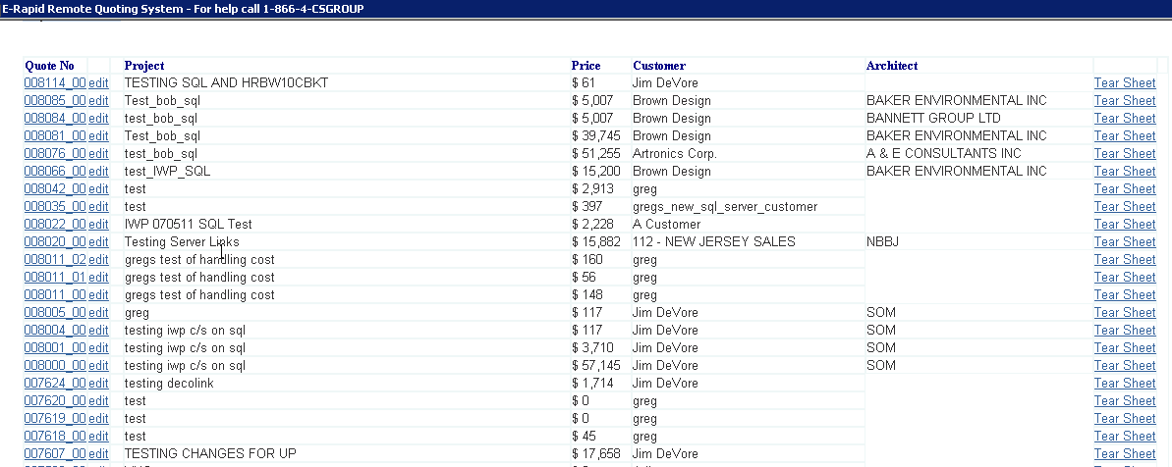

Click on the quote number of the quote to be changed to an order.

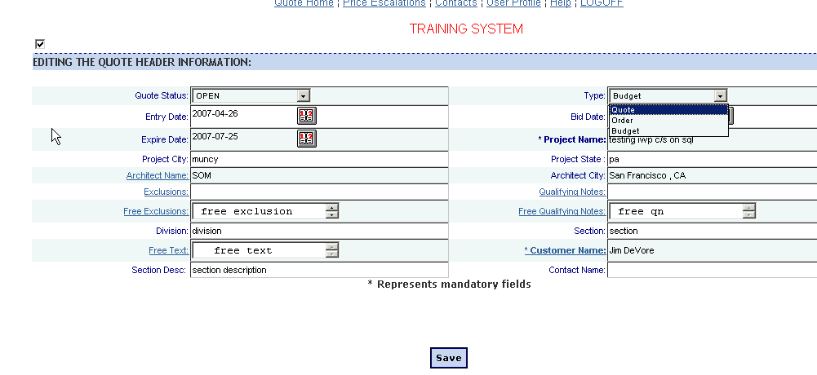

In the “Type” field, click on “Order.”

Click on the “Save” button at the bottom of the screen.

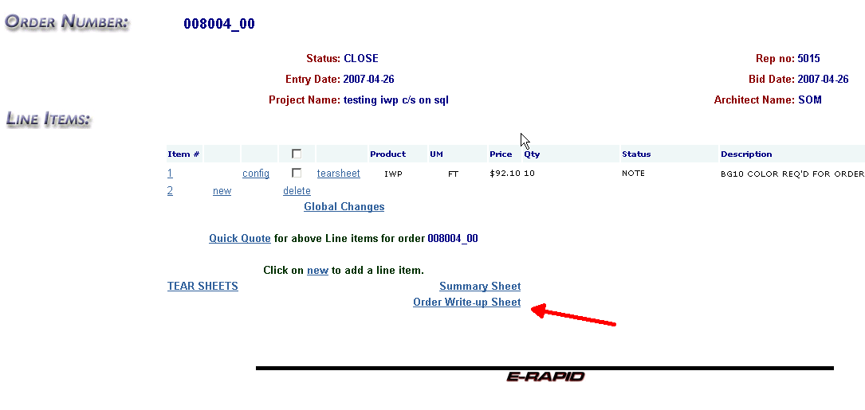

At the bottom of the screen, click on the words: “ORDER WRITE-UP SHEET” to access the order write-up sheet.

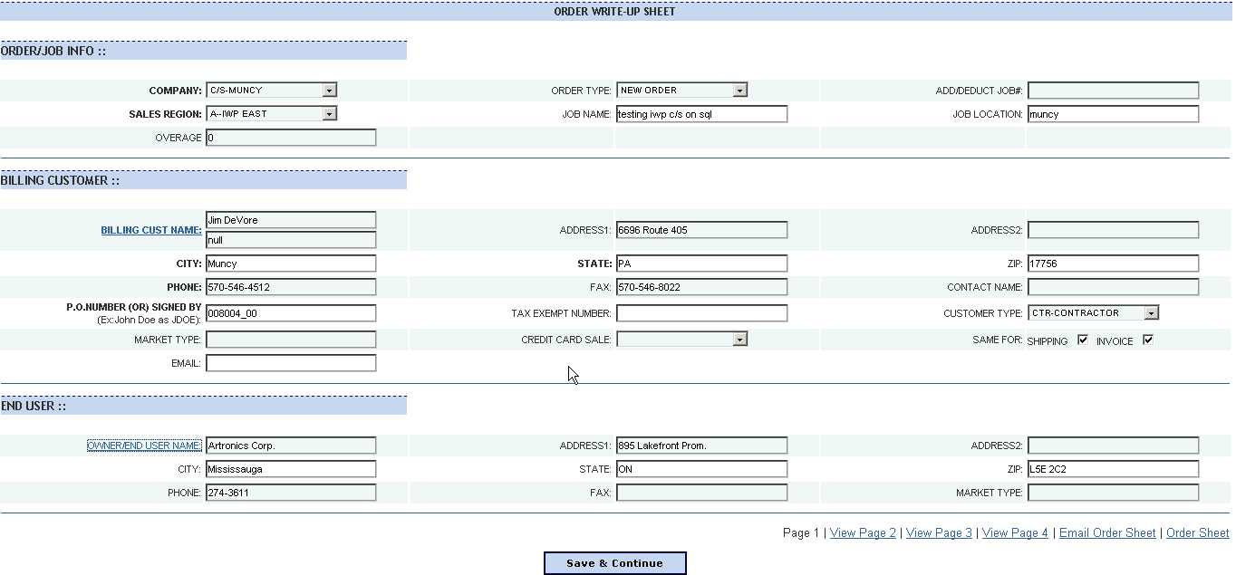
This is the first screen required for the write-up sheet. All bold boxes are mandatory selections/entries. An error message will pop up if those fields are not filled in, noting which are missing.

Note that the Billing Customer information will be automatically populated if the “Use for Billing” box was checked in your customer information. If this box was not checked the information will need to be entered.

If a credit card is to be used, click on the selector in the “Credit Card Sale” field. Two options appear:
- Credit Card – This selection will provide an area on the third write-up screen for entering the credit card information.
- Credit Card (Same as billing) – This selection will populate the credit card information with the billing customer’s name, address etc.

Note that the ship to information on the next screen will be automatically populated with the same ship to address as the billing customer if the “Same for shipping” box is clicked off at the end of the second block (Billing Customer). Additionally, if the invoice to address is the same, check that box also.

Hit Save & Continue when complete.

Each underlined title, such as BILLING CUST NAME:, are links to selection or entry boxes:

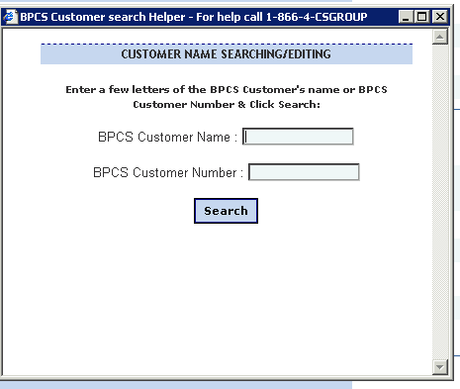

Simply type the first part of the data in and hit the search button in this instance. A list of potential items will populate the next screen, highlight the appropriate one and hit select.

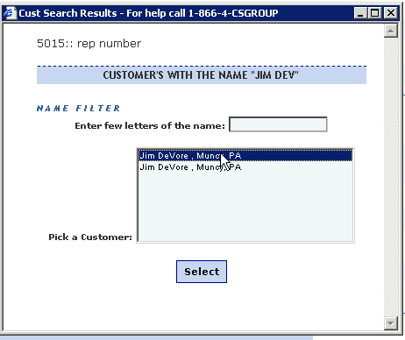

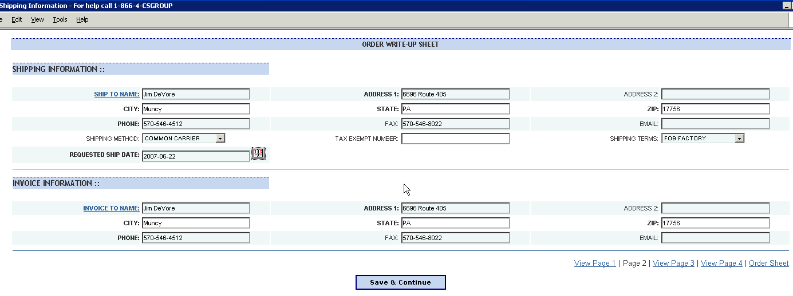

To go back to a screen at any time, click on the blue text at the bottom right of the screen. For example the “Page 1” text will take you back to page 1.

Fill out the second screen as required.

When complete, click on the “Save & Continue” button at the bottom of the screen.

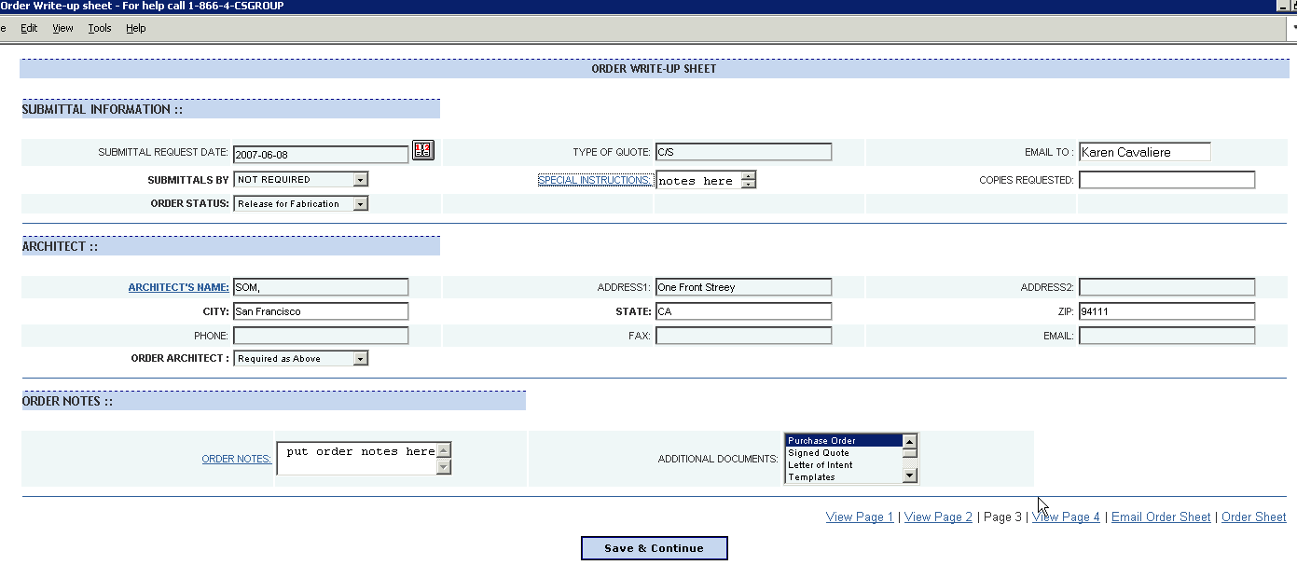
Fill out the third screen as required.

Note that the following two fields on this screen are underlined in blue lettering:
- Special Instructions (Under Submittal Information)
- Order Notes (Under Order Notes)
Both of these have text boxes that pop up by clicking on the underlined blue text.

Note that the “Order Architect” field has a drop down box. If there is not an Architect on the project, select “None” in that box.

To select multiple ADDITIONAL DOCUMENTS:, hit the Ctrl key and select all required with your mouse.

When complete, click on the “Save & Continue” button at the bottom of the screen.

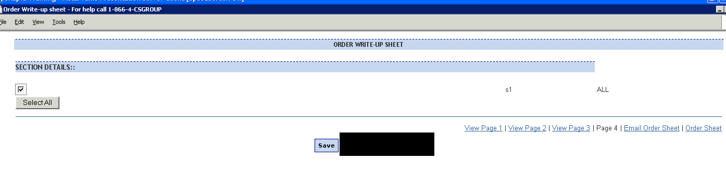
Select the appropriate sections to close, or use the select all button, then hit the Save button.

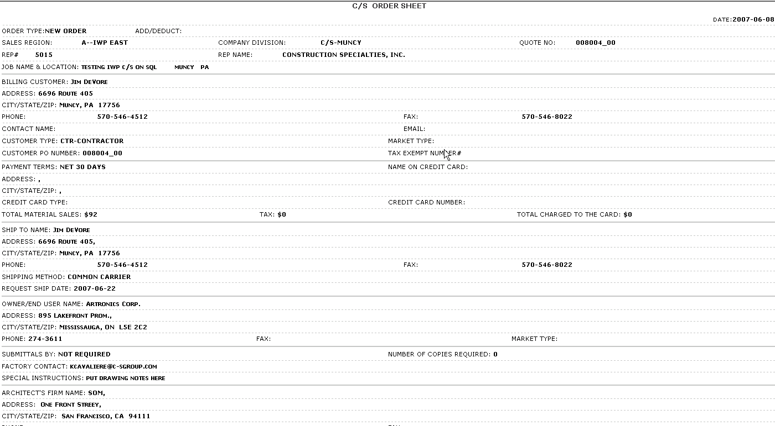
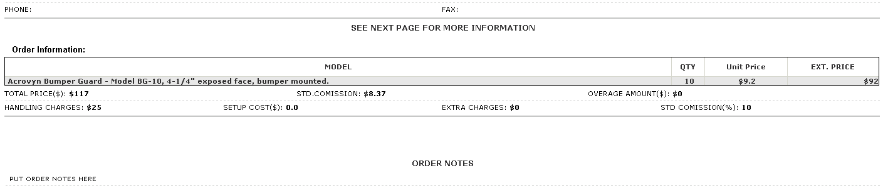

Review the write-up sheet on screen for errors.

When complete, print out the order write-up sheet, or save a copy to your computer’s hard drive.

Fax or email the order write-up sheet to the appropriate contact along with the customer’s purchase order or signed quote.

End

